|  |  |  |
| --- | --- | --- |
|  | **Surname, First name** | **Mrs. Bardina, Marina P., Ph.D.** |
|  | **Address** | 23/1, Universitetskiy prospect, Apt.21 |
|  |  | 119330 Moscow |
|  |  | Russian Federation |
|  | **Telephone** | **+**7 (916) 184 73 64 |
|  | **Phone/Fax** | +7 (499) 147 05 14 |
|  | **Email:** | mpbardina@gmail.com |
|  | **Nationality/** | Russian Federation |
|  | **Date of Birth** | May 9, 1950 |

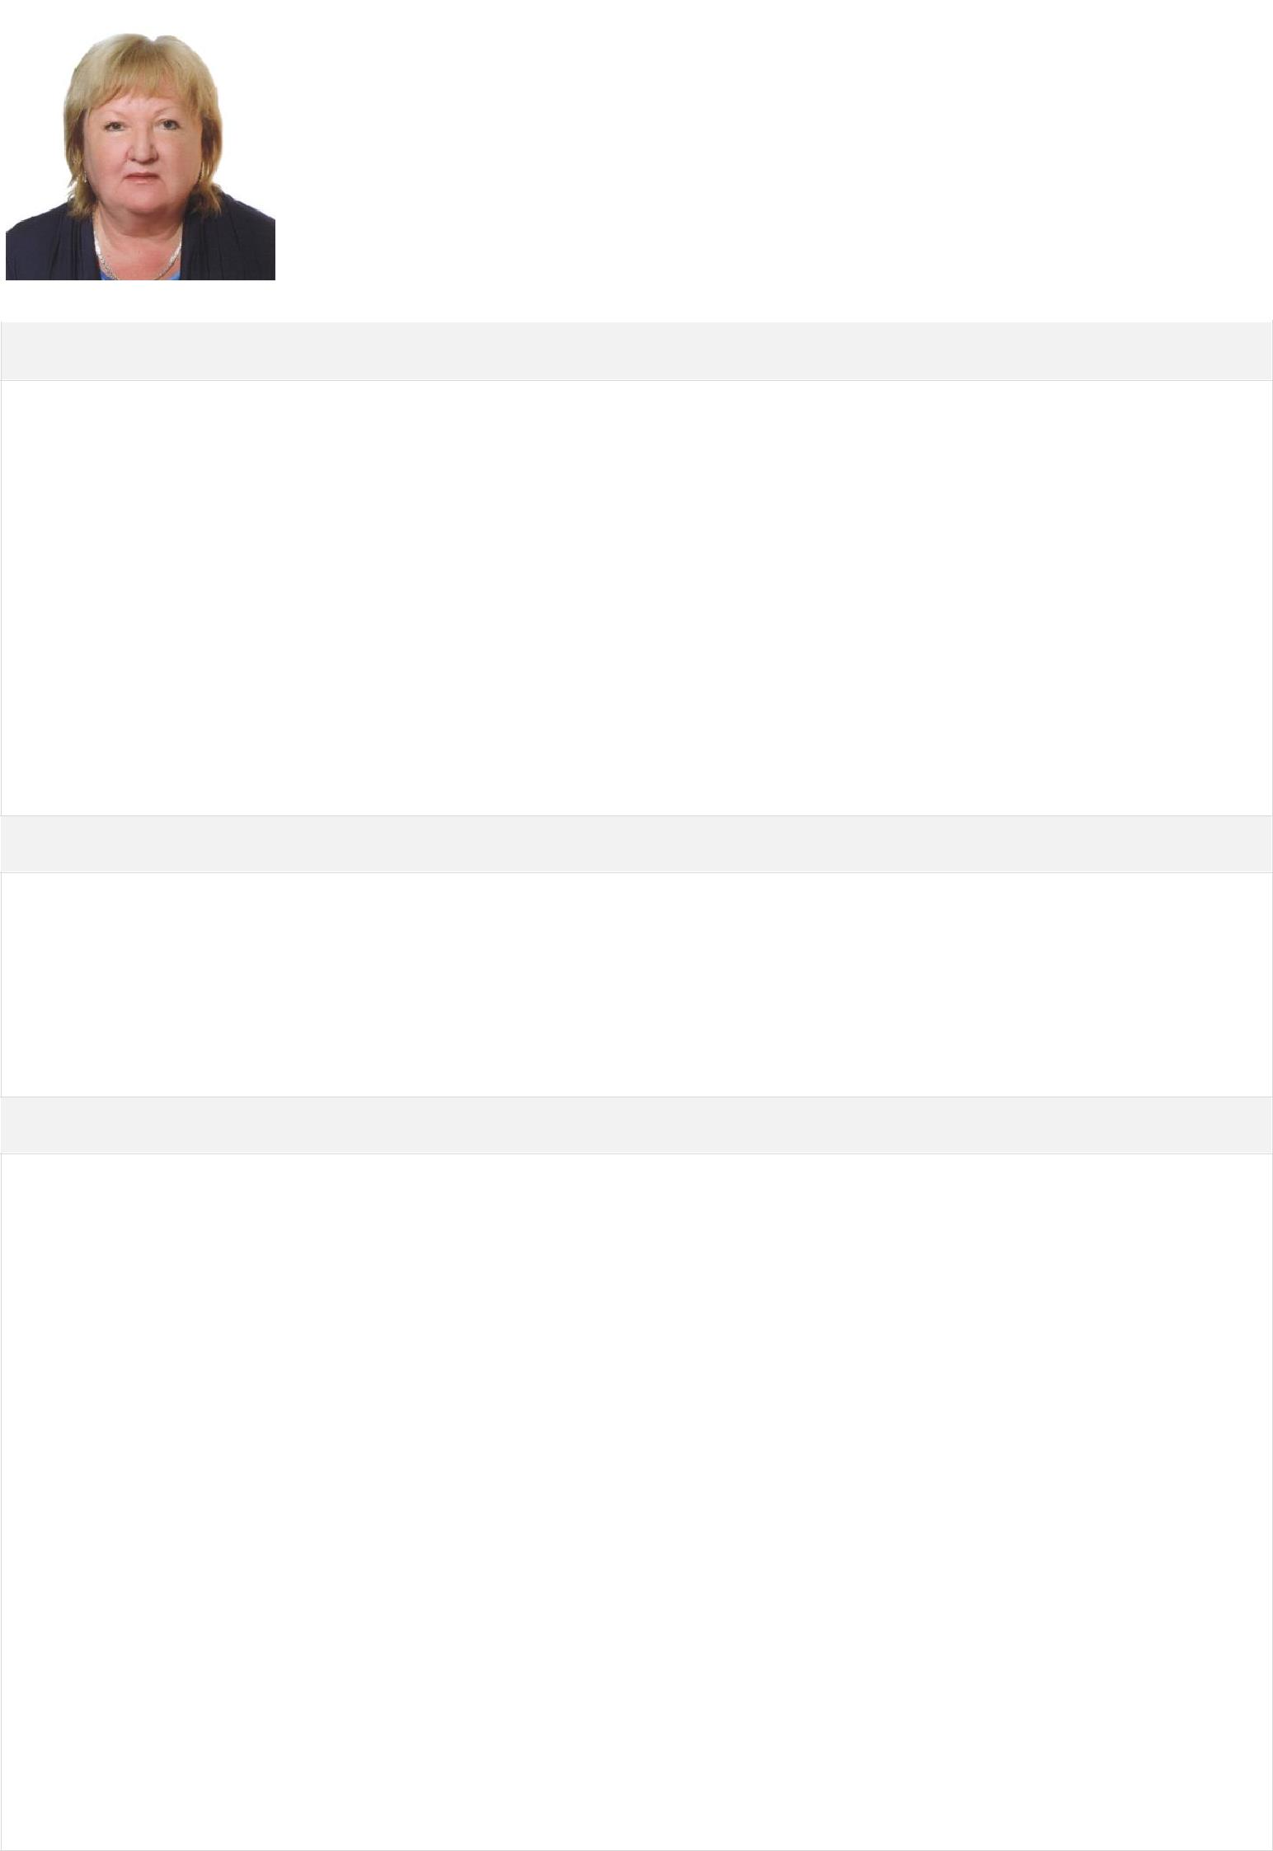

**Educational/Professional Memberships**

Graduate Degree in Law – Law Faculty of Moscow State University (1967-1972);

Postgraduate – Institute of State and Law of the USSR Academy of Sciences (1972 –1976). Ph.D. Degree (Law) – Institute of State and Law of the USSR Academy of Sciences (1976)

– Member of the Editorial Board of the Journal “State and Law’’

– Member of Editorial Board of the Journal “International Public and Private Law

– Member of Russian Association of International Law

– Member of Expert Council of Arbitration commission ICC Russia

**Current Position**

– Professor of the Chair of Private International Law of All-Russian Academy of Foreign Trade (since 1999 - till present);

– Senior Researcher of the Institute of State and Law of the Russian Academy of Sciences (since 1976 - till present)

**Professional Experience**

– Legal research in the field of regulation of international commercial relations, state regulation of foreign trade relations, the problems of applicable law in international commercial arbitration. (Institute of State and Law of Russian Academy of Sciences since 1975 till now)

Delivering lectures on Private International Law and on Legal regulation of foreign trade relations:

– Financial Academy at the Government of Russian Federation (1997 –1998);

– Law faculty of Moscow High School on Economic and Social Studies (2004-2005);

Lecturing abroad On Legal Regulation of Foreign Trade Activity in Russia (in English):

– Greece, Institute of Public International Law and International Relations of

– Thessaloniki, 1991;

– France, Nanterre University, Paris, 1997;

– Finland, Master Comparative Law Program, International Summer School, ISS-98, 1998;

– Poland, Łazarski School of Commerce and Law, Warsaw, 2004.

**Arbitration Experience**



**Serving on the following panels of arbitral institutions**:

in Russia

– International Commercial Arbitration Court at the Chamber of Commerce and Industry of the Russian Federation (ICAC) (from 1991- till present);

– Arbitration Court of Russian Energetic Systems – from 2005- Arbitration Court at the Foundation «Law and Economy of Fuel-Energetic Complex” (from 2001 - till present);

– Arbitration Commission of Moscow Inter-Bank Currency Exchange (from 2003 - till present);

– Arbitration Court of the Russian Union of Industrialist and Entrepreneurs (RSPP) (since 2009 – till present);

– Gazprom Arbitration Court (since 2010 - till present);

– Court of Arbitration for rеsolution of Economic Disputes at the Chamber of Commerce and Industry of the Russian Federation (from 2011 - till present);

– Arbitration Court of NP ”Energostroy” (since 2012- till present);

– Arbitration court of the Association of Russian Banks (since 2012 - till present);

– Russian Arbitration Association (RAA) (since 2014 – till present);

Abroad:

Kuala Lumpur Regional Centre for Arbitration-since 2014

Singapore International Arbitration Centre –since 2015

Hong Kong International Arbitration Centre-since 2015

**Participation Experience in Commercial Arbitration Abroad** - as an arbitrator (Arbitration Instituteof SCC; Arbitration of ICC, arbitration ad hoc) and as a party-appointed expert and as an expert, appointed by the tribunal - Arbitration Institute of SCC, Arbitration at Zurich Chamber of Commerce, LCIA, Arbitration of ICC, Netherlands Arbitration Institute.



**Publications**

**Publications (about 100) in Russia and abroad**. ( the list of the main publications since 2000enclosed as a separate document)



**Languages**

English – fluent.

Russian – native.